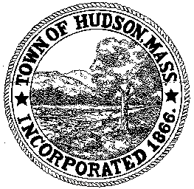

CONSERVATION COMMISSION
78 Main Street, Hudson, MA 01749
(978) 562-2020

Paul Byrne, Chairman W. Minot Wood, Vice Chairman David Esteves, Member

Terrence Joyce, Member Leif Longtine, Member Joseph Rodrigues, Member Al Tashian, Member

Meeting Agenda
September 20, 2012 7:00 P.M.

- Preliminaries
  - Open Meeting
  - Roll Call

2.0 New Business
2.1 RDA 437
Applicant: Richard and Nicole DiPersio
Location: 4 Julian Lane
Project Description: the construction of an in ground swimming pool and patio within the existing lawn area. No trees will be cut or disturbed.

2.2 Request for Certificate of Compliance
DEP 190-0541
Applicant: Robert Flynn
Location: 43 Broad Street/Houghton Street
Project Description: Parking area

2.3 Senior Center

2.4 Minutes: September 6, 2012

3.0 Adjournment

